Title: On Impedance in Electromagnetic Induction and Capacitance

(or something else if u can make it better)

Abstract

This paper details the behavior of inductance and capacitance in common circuits as measured by a variety of experiments, which were generally consistent with theory. A V-i phase shift of (37.02+-. 02)° was predicted in an RC circuit, and a (36.7 $±$.1)° phase shift was observed. This resulted in a expected Lissajous figure. In the CLR circuit, a resonance frequency of 15890±20Hz was observed, and a current dampening curve i(t)= $(-2.83±.02E-4)e^{-2500±50t}sin((-2.83±.02E-4)t)$ was modelled. The energy operations in a transformer were also analysed, and magnetic principles such as the Biot-Savart Law were applied to design and thoroughly test a Matlab simulation.

Sources of Error:

Equipment is usually reliable in electrical experiments, especially when compared to mechanical ones. Nevertheless, there were a few preventable sources of error.

The resistance and any inductive effects of the wires was not measured and assumed to be zero. Furthermore, different equipment was used across different days, leading to minor inconsistencies in the data.

Error could have been avoided when setting up the solenoids for circuits 4 and 5. This is due to the unmatchable precision required by theory. As demonstrated, even the smallest perturbation in position can cause drastic changes in b-field. Furthermore, the ambient b-field in the room was not well documented.

Conclusion:

This report covers the simple yet ubiquitous phenomena in AC circuits and electromagnetism. Further research may be developed into exact cause and theoretical behavior of transformers at high frequencies, and magnetic field simulations where Biot-Savart law does not apply.

6 pages

0.5 abstract and names

0.5 sources of error conclusion works cited

0.2 introduction

0.5 method

0.8 theory

3.5 analysis

0.5 transformer

1.5 solenoid bonus

Rc rlc

Theory

Biot savart

That magnetic force thing

Transformer citing

Capacitor equation

Inductor equation

Ohms law

Method

The internal impedance of the function generator was in series with the power supply. Additional resistances were added to the configuration and the potential across the function generator were measured. From this, the internal resistance of the function generator was calculated by comparing the potential ratios. The impedance of the function generator was matched for all relevant circuits using the experimental function generator impedance.

A (46.2±.3)Ω resistor and (98.2 $±$.8)uF capacitor were connected in series to an AC function generator to create an RC circuit. The frequency was set to 47.0 Hz to obtain a reasonable phase shift. The potential was measured with a LabQuest across the resistor and across both the resistor and the capacitor. Then, as the frequency was varied, potential differences were recorded..

A series CLR circuit was constructed with a (51.0 $±$.2) Ω resistor, (9.8 $±$.5)mH inductor and (10 $±$ 1)nF capacitor. The potential of the resistor was measured with a multimeter, varying the frequency from 0 to 30kHz. An LC circuit was in a configuration such that a switch would disconnect the capacitor from a potential source and connect it to an inductor. Then, the natural frequency of this circuit was measured with an oscilloscope.

By introducing a switch in the circuit, a closed loop containing just CLR can be constructed. When the switch is closed, the current continues to oscillate in the loop as it is slowly damped by the resistor. This current was computed from the potential drop across the resistor as measured by a multimeter

The inductances and capacitances of the components were determined experimentally with a corresponding DC RL or RC circuit, chosen with a resistance to obtain a reasonable time constant. The V-t values measured by the LabQuest were put through a GRG nonlinear algorithm to minimize the residual sum of squares between the experimental data and an initial model generated by the components’ advertised values.

An iron magnetic core and 1200 and 300 turn solenoids were used to create a transformer with a 4:1 turn ratio. A function generator was connected to the primary winding. The input and output potentials were then measured with multimeters.

For the b-field experiments, a retort stand and clamp were used to secure the probe to minimize fluctuations in the Hall effect sensor readings. The position of the probe was re-adjusted after every measurement. Using the LabQuest, an average was produced and recorded over 10 seconds at 25 measurements per second.

In the final experiment, multiple configurations were verified by the simulation, which was then replicated in the laboratory. The method used in experiment 4 was repeated with some additions. Retort stands were used to ensure that the coils remained in its desired angles. Tape measures and grid paper were secured on the lab bench to create a coordinate system that gave the the position of the probe.

Analysis

Impedance matching: Impedance must be matched between input and output as it generates the highest power according to maximum power transfer theorem.When impedance of load is greater than that of source as the resistance of the load lowers power. If impedance of source is higher than load, then the total power generated goes up, but because the resistance is lower at the load end, most of the power is dissipated at the source as opposed to the load.

Measuring impedance: The output impedance of the function generator is calculated by connecting two resistors that have different resistance. We first connect one resistor. The voltage of the circuit will be measured as the peak-to-peak amplitude of the sine wave displayed on the oscilloscope. The first resistor is replaced by another resistor that halves the amplitude of the voltage curve. The input impedance of the oscilloscope is much higher than the resistance of the resistors connected, which means that it will not affect the curve. Impedance is calculated by the equation below

$Ro =\frac{R1(1-\frac{V1}{V2})}{\frac{V1}{V2}}$ ( - R1/R2 in the denominator; doc is retarded)

Significance of Lissajous Figures: There are no discontinuities in the figure, which indicates that the frequency between the two harmonic motions are very similar. The ellipse is slanted towards the horizontal axis, which indicates that it has an angle(or phase shift) of less than 45 degrees.

**2. Rlc**

**AYON THING**

**PICTURE OF THE PHASE SHIFT PLOT**

**ANALYSIS**

[impedance magnitude general] Z = sqrt(R^2 + X_T^2)

[phase angle RC] phi = arctan(X_T/R)

[reactances] X_L = omega*L, X_C = -1/omega*C

The RC phase shifts created with components used in the previous DC lab are only reasonable at very low frequencies (<1Hz). Therefore, different components were used to obtain an RC phase shift and conform to impedance matching.

The reactance of the capacitor can be obtained using [impedance eqn], with the total impedance defined as the ratio between max potential and current. A capacitive reactance of 33.6 ohm was found compared to the theoretical 34.5 ohm.

In an AC series RC circuit, since the current is in phase with the potential across the resistor, the V_R-t graph had the same phase shift as the i_T-t graph with respect to the V_T-t graph. The theory of phasors modelled the phase shift and total impedance by taking into account the resistance and reactance. The Solver tool in Excel generated a sinusoidal fit of

[two equations of potential vs t]

From this, a phase angle of 37.02° was computed as the difference in the phase shifts of the two sinusoidal fits. The theoretical phase angle between potential and current is (36.7 $±$.1)° as computed by [phase angle equation].

(Insert lissajous graph)

The Lissajous figure was generated by plotting V_R vs V_T. The curve can be modelled with a parametric equation using the two sinusoidal waveforms. The Lissajous figure appears to be continuous, which implies that V_R and V_T had a very similar frequency as expected.

The RC circuit was then considered in the frequency domain. Using [reactance of cap], as the frequency approaches 0, the reactance goes to infinity, whereas when the frequency approaches infinity, the reactance goes to zero. By[KVL], V_C **is approximately** V_S at low frequencies and V_R **is approximately** V_S at high frequencies.

(Graph, %Vt-f)

In the above graph, the intersection point given by each fit is also known as the cutoff frequency. At the cutoff frequency, the potential across the resistor of the circuit is equal to the potential across the capacitor. This was graphically determined to be 35.12 Hz

This property of RC circuits is applied to many real-world applications. For example, both high and low pass filters are used in television signal splitters to be able to tune into the correct frequency. (SOURCE HERE)

RLC

(insert graph here)

The resonance frequency was obtained via a GRG nonlinear optimization to be15893±1Hz, which is close to the predicted value of 15919±7Hz using [6].

The resonance frequency of the described circuit is dependent on the function generator. However, if the driving source is removde, the oscillation will continue, decaying at a rate based on the resistance of the circuit. If R=0, this oscillation will continue indefinitely.

The damping response of the RLC circuit was due to the resistor exhibiting Joule heating, which is the process of converting electrical current into heat. To model this, the Laplace transform was applied to a differential equation obtained from Kirschoff’s Circuital Laws, putting it in the s-domain. A solution was then algebraically determined, and after an inverse Laplace transformation, the solution in the t-domain was obtained as follows.

i(t)= $(-2.83±.02E-4)e^{-2500±50t}sin((-2.83±.02E-4)t)$

[eqn] defines an underdamped transient response. Unfortunately, the time constant was very small, resulting in the oscillations dying out faster than can reliably be measured. The results of this experiment were inconclusive.

The frequency at which the LC circuit oscillated at was 15906±Hz, only a fraction of a percent from the resonance frequency of the driven RLC circuit, confirming the theoretical mechanisms of a capacitor and inductor.

Similar to the high pass filter, RLC circuits have their own cutoff frequencies. An RLC circuit has two points where the potential across the resistor is equal to the potential across the LC section. The bandwidth of the circuit is measured between these two cutoff frequencies.

A quantity related to the bandwidth is the quality factor (or Q factor). The Q factor is dimensionless and is inversely proportional to the fractional bandwidth.

RLC circuits have many practical applications, with various bandwidths and Q factors. For example, radio receivers and television sets use them to only permit frequencies within the bandwidth to pass, which effectively allows for tuning.

Dampening sinusoidal:

**Insert circuit diagram?**

**3. Transformer**

The output potential difference began to drop off at (22.3±.2)kHz. The energy losses in a transformer were primarily due to winding and core losses. Some losses were unavoidable and not connected to frequency such as Joule heating through the windings. However, effects such as hysteresis loss and Eddy current losses exist within the core and are directly related to frequency. The energy losses in the transformer can be attributed to these factors.

Another possible explanation for the behaviour of the transformer is a result of all solenoids possessing a parasitic capacitance, which becomes more apparent as the frequency increases. This results in the solenoid behaving like a capacitor. This parasitic capacitance effectively renders the transformer into a parallel RLC circuit, with the resistance of the circuit originating from the resistance of the wire, with its resonance near the peak of the Vout vs f graph.

Many mathematical models were explored but none were sufficient due to the complexities of the transformer.

**4. Solenoid + Bonus**

The square solenoid data were compared to the data generated by the sim, with the values matching the theoretical values.

Figure(X)

The more interesting scenario occurred when the Helmholtz coils were used. Depending on the distance between the two coils, different B-fields were obtained. To minimize the variation of the magnetic field strength in between the coils, the distance between the coils was set to equal the radius of the coils.

FIGURE (X)

**Fig X. Magnetic Field Strength vs. Position.** Instead of a uniform field between the coils, a bimodal distribution was obtained. The B-field weakened in the middle as the distance from each of the coils is increased

As seen in the simulated and experimental plots, the two fields line up closely. However, small differences remain. At 47.6cm, the graph greatly deviates from the expected values. While an argument could be made for experimental error, the fact that this specific probe caused erroneous readings was cause for suspicion. Studies performed by Lui et al. and Paun et al. reveal that most hall effect probes are aligned in a cross-shaped sensor. The potential difference across two of the plates are then used to compute the b-field. However, once this potential is altered, the reading changes as well.

According to Paun et al., the correction factor would be as shown.

EQ (X)

This correction factor would increase as the Hall Angle increases. While this angle is perfect on purchase, consistent usage will often break down one end of the plate. From the experimental data, 0.8 years of usage was inferred. Consistent usage rate of the 5-6 year old equipment (between labs and the Algonquin Expedition) would add to around 0.8 years, confirming the error within our data.

Note the presence of a B-field at areas where neither coil was facing, as in figure (X).

The magnetic field lines were rendered at the spot of the magnetic field, where chaotic field lines were found. Since the field lines are far apart, it very slightly altered the ambient. This continues to support the validity of the simulation.

To continue this investigation, a third, smaller, solenoid was energised and placed at a precomputed location. This created a small volume with no net B-field in the x and y directions, and a net upwards B-field in the z direction. The results would be stunning, amidst all the chaos in the B-field, a volume would be calm enough to allow a small charged particle to orbit around the field lines and remain equidistant from the ground.

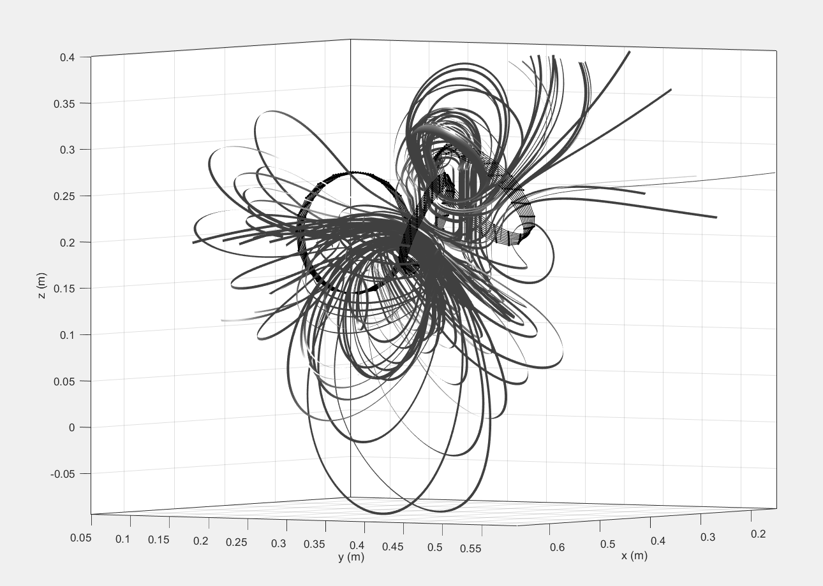

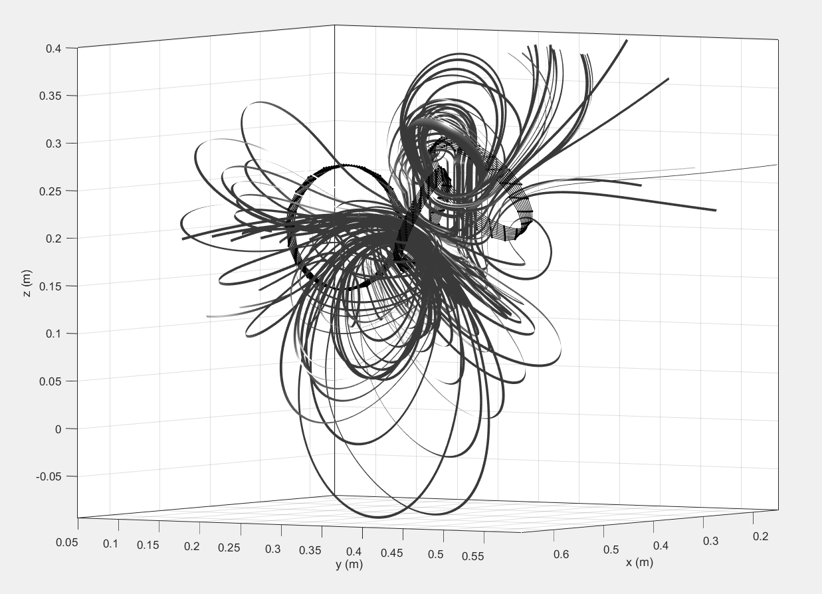

**Fig X. Three solenoids and their respective flux tubes.** Notice the deliberate phenomena set up in the upper right corner, the field lines are near vertical meaning the horizontal components of the B-field are negligible. The field lines are almost laminar amidst the remaining turbulence.

|  |  |  |  |
| --- | --- | --- | --- |
|  | BX (T) | BY (T) | BZ (T) |
| Simulated | 4.523E-8 | -6.1656E-7 | 0.0149 |
| Actual | (2.8±.1)E-5 | (-2±1)E-6 | (2.1±.1)E-3 |

**Fig X. Measured vs Simulated B-Field at (50.75, 27.00, 23.50) cm.** The simulation had a current of 10A, and the experiment had a current of (0.611±.005)A.

Unfortunately, the energized solenoids did not conform to the simulation. The current needed was too large and could not be supplied reasonably. Furthermore, the precise orientations required in the configuration was unable to be matched experimentally. Regardless, the experiment was an interesting insight into the operation of multiple solenoids and the capabilities of the simulation.

Sources

Conclusion

\begin{center}

\begin{tikzpicture}[trim axis left, trim axis right][scale=0]

\begin{axis}[xlabel={$x$ (m) $\rightarrow$}, ylabel={B-field (mT)$\rightarrow$}]

\end{axis}

\end{tikzpicture}

\captionof{figure}{Hyello}

\end{center}

x xerr y yerr class

-0.14 0.0005 0.09158 0.01 0

0.135 0.0005 0.0919 0.02 0

-0.13 0.0005 0.09463 0.01 0

-0.125 0.0005 0.10118 0.005 0

-0.12 0.0005 0.10565 0.02 0

-0.115 0.0005 0.10747 0.01 0

-0.11 0.0005 0.11548 0.01 0

-0.1 0 0.1655 0 1

-0.095 0 0.1834 0 1

-0.09 0 0.2022 0 1

-0.085 0 0.2216 0 1

-0.08 0 0.241 0 1

-0.075 0 0.2598 0 1

-0.07 0 0.277 0 1

Original

- Graph looks interesting

- Too far apart

- We used this to verify sim

Sim

- Used sim to find an orientation with 2

- Rigging set up so x + z were cancelled

- And then used Helmholtz with interesting orientation

- Our thing is too perfect

- Flex our advanced analysis. Analyze those

- Long winding solenoid = three separate ones

- What if we added a third one?

By applying KVL to the rightmost loop, the following differential equation was obtained.

$L\frac{di(t)}{dt}+R⋅i(t)+\frac{1}{C}\int_{0}^{t}{}i(t)dt+v_{0}=0$

Where i(t) is current as a function of time

(chances are L, R, C, v0 were defined previously. V0 is source potential)